Application Manager Design

Date | Version | Author | Modification
2006-10-09 | V0.1 | Chaowei Song | Framework design

Application Manager Design 1
1. Overview 3
1.1 Function 3
1.2 Features 3
2. Layout design 3
2.1 Main Layout 3
2.1.1 Application Menu 4
2.1.2 Filter Menu 5
2.1.3 Navigation Area 5
2.1.4 Toolbar 6
2.1.5 Details Area 6
2.1.6 Footer Area 8
2.2 Request widget 8
2.3 Request picture 9
3. Related libs 9
4. Implementation Details 10
4.1 Initial statuses 11
4.2 Normal Statuses 11
4.3 Confirm Statuses 12
4.4 Apply status 12
4.5 Show help status 13
4.6 Set status 13
4.7 Set update sources status 13
4.8 Install single application status 13
5. Interaction 14
5.1 External Interaction 14
6. Interface 14
6.1 External Interface 14
7. Unresolved Issues 14

Overview
This document defines the Application Manager, an application designed manage both the applications and the actual system software for the OpenMoko platform. This is a Native Stylus-Based application.

Function
The application manager has the following characteristic.
  - Only one instance is running at any time.
  - It is able to download available packages info from network.
  - It is able to install applications to local file system.
  - It is able to install available applications from net work.
  - It is able to install applications from local file system or external memory card.
  - It is able to update all installed packages from net work.
  - It is able to remove applications that installed.

Features
  - It is able to update his system (kernel, core libraries, etc…)
  - It is able to install applications to external memory cards.
  - It is able to configure the update sources.
  - It is able to configure the sources.
  - There is a detailed help.

Layout design

2.1 Main Layout
The layout of application manager is given as below.
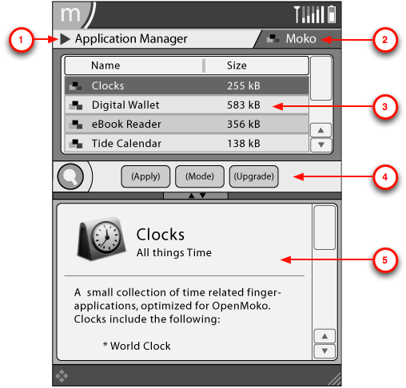
The details of each mark:
- Application Menu -- Additional options related to application objects. This widget is a button. And a pop-up menu will show when this widget be clicked.
- Filter Menu -- Filtering options for the list of applications. This widget is a button. And a pop-up menu will show when this widget be clicked.
- Navigation Area -- List of applications based on current filter. This widget is a tree view widget. There are three columns in the tree view. They are status, name and size.
- Toolbar -- Primary commands available to applications.
- Details Area -- Detailed view of current selected application.

The details of each part are given as below.

2.1.1 Application Menu
Item | Action | Constraints
Update Sources | Opens Dialog to show status.
Sources | Opens Dialog to show Sources
Install Single Application | Opens Dialog to browse for file
Help | Opens Help Viewer Application with help for this application

2.1.2 Filter Menu
Item | Action | Constraints
<category> | Displays all applications from this category (based on the "section" tag of the application)
Search Results | Displays all applications matching current search string
Installed | Displays all installed applications
Upgradeable | Displays all upgradeable applications | Grayed-out when zero applications can be upgraded
Selected | Displays all selected applications | Grayed-out when zero applications are selected

2.1.3 Navigation Area
Displays list of applications from current category using the Navigation Widget. Has the following structure:
Item | Action | Constraints
Column 0 | Status Icon
Column 1 | Displays the application's name
Column 2 | Displays the application's size
Tap selecting a row, will display corresponding application information in the Details Area.
Applications are installed by tapping on the Status Icon. On Tap the Popup Menu with the following structure is opened:
Item | Action | Constraints
Unmark | Unmark the application | Grayed-out if application is not yet marked
Mark for installation | Marks application for installation | Grayed-out if application is already installed
Mark for Upgrade | Marks application for upgrade | Grayed-out if application is not upgradeable
Mark for Removal | Marks application for removal | Grayed-out if application is not installed

2.1.4 Toolbar

Search
Search re-indexes, after every key-press, the application membership of the Search Results category.

Action Buttons
Apply
Item | Action | Constraints
Apply | Opens Dialog showing downloading status | Performs no action when zero applications are marked

Mode
Item | Action | Constraints
Mode Summary | Activates Summary Mode for Details Area
Mode Dependencies | Activates Dependencies Mode for Details Area

Mark all Upgrades
Item | Action | Constraints
Mark all Upgrades | Marks all upgradeable applications

2.1.5 Details Area
A Details List that behaves different in each of the following modes:

Summary Mode
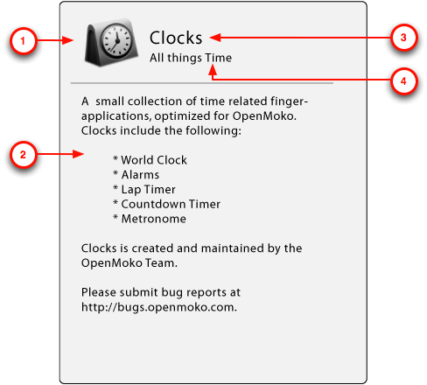
- 1) Icon -- Application's icon.
- 2) Summary -- Summary of the application's features and usage.
- 3) Name -- The name of the application
- 4) Tagline -- Very short tagline of what the application does.

Dependencies Mode
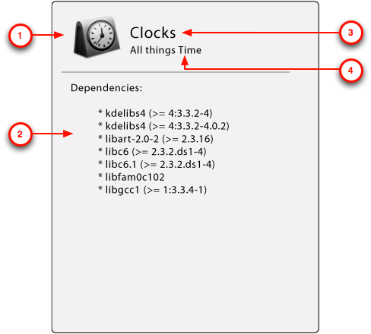
- 1) Icon -- Application's icon.
- 2) Dependency list -- A list of all the libraries this application depends on.
- 3) Name -- The name of the application
- 4) Tagline -- Very short tagline of what the application does.

2.1.6 Footer Area

Status Bar
Display the total number of applications in the current category.

2.2 Request widget
The application manager needs the following widgets that been designed.
- Popup menu widget
The application menu of application manager is a popup menu widget. So it needs Mickey complete this widget.
- Filter menu widget
The filter menu of application manager is a filter menu widget. So it needs Mickey complete this widget.
- Navigation List widget
The package list of application manager is a navigation list widget. So it needs Mickey complete this widget.
- Tool bar widget
The search, mark all upgradeable, unmark all and apply are section of a toolbar. So it needs Mickey complete this widget.
- Complex widgets
The detail info will be designed as a combine of complex widgets.

2.3 Request picture
At the navigation area, it displays different bitmap on each row to figure out the status of the package. It needs six different bitmap. The meaning is given as below.
Not Install
Installed and can’t Upgrade
Upgradeable
Mark for Install
Mark for remove
Mark for Upgrade

Related libs
The following diagram represents the libs that application manager needed.
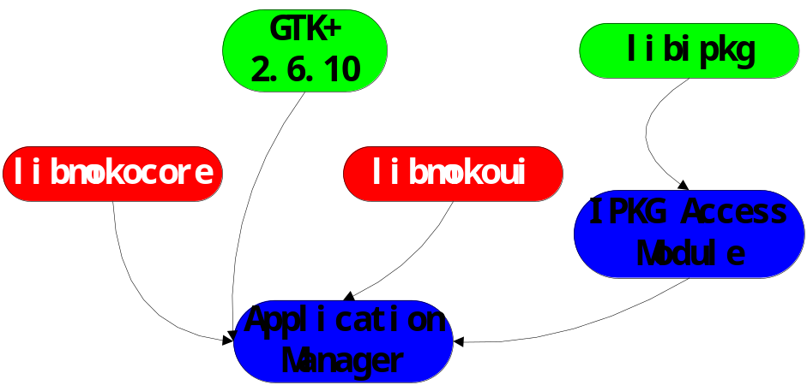
- The GUI of application manager will base on GTK+ and libmokoui.
- IPKG access module provides an interface between libipkg and application manager.
- Application manager manages packages through IPKG access module.
- Application manager sends d-bus message to the main menu through libmokocore after install/uninstall/update packages.

Implementation Details
The following diagram represents the status machine of application manager.
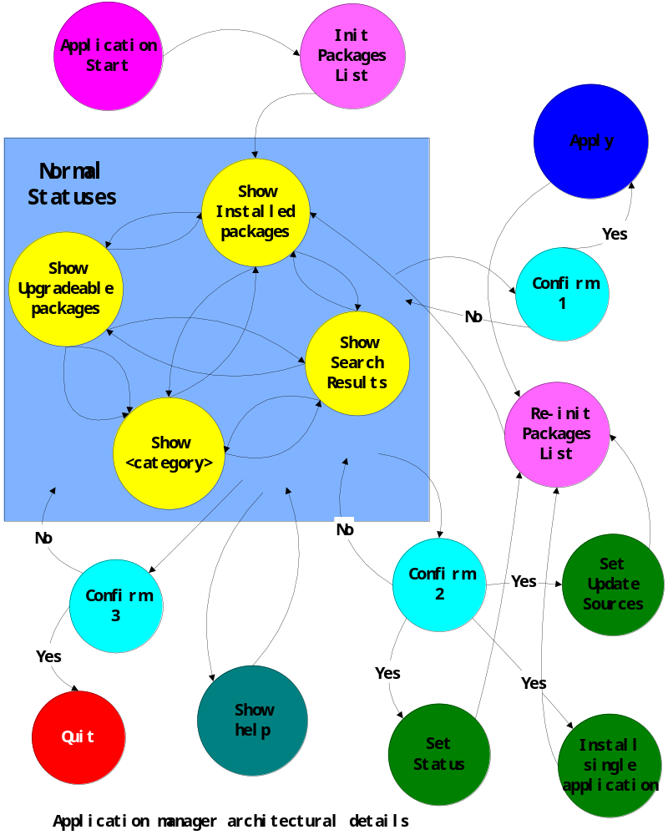

4.1 Initial statuses
The initial statuses are including “Application Start”, “Init packages list” and “Re-init packages list”. At these statuses the application manager initializes all sources for the user interface.

Application Start: When the application manager starts up, it first enters the “application start” step. At this step, the application manager initializes the main interface. After init success, the application manager will enter the “init package list” step.
Init Packages List: At this step, the application manager initializes the libipkg, and loads all packages info to memory. Build all need indexes for the package list, etc installed packages index, upgradeable packages index, each category packages index, and a new selected index. Then build the installed packages list for display. After that it enters the “Show installed packages” step.
If loads all packages to the memory are too slow, it only loads the installed packages list, and after display the installed packages list to user, it loads all packages list to memory at the background.
Re-init Packages List: After the application manager installed/upgraded/removed packages, or changed the update sources/status, the packages info will be changed. Application manager need reloads all packages info. At this step, it destroys all old packages info, index, and display list. Then loads all new packages info to memory, build the index, and build the installed packages list for display. Then it enters the “Show installed packages” step.

4.2 Normal Statuses
The normal statuses are including “Show Installed packages”, “Show Upgradeable packages”, “Show Search Results” and “Show <category>”. The normal statuses are the main interface of the application manager. When the application manager is in the normal statuses, user can look through the packages that installed, available and upgradeable. User can look through the details info of a package. User can mark the packages for preparing install, remove, upgrade, or unmark. User can change the filter to display different packages list. User can input package name to searching the package from current packages list. User can apply his choice to installing, upgrading, removing packages. And user can select to entering the other status.

Show Installed Packages: At this status, the application manager displays the installed packages list on the navigation area.
Show Upgradeable Packages: At this status, the application manager displays the Upgradeable packages list on the navigation area.
(A) Show Search Results: At this status, the application manager displays the search result list from current filter list on the navigation area.
(B) Show Search Results: At this status, the application manager displays the search result list from all packages on the navigation area.
Show <category>: At this status, the application manager displays the selected category packages list on the navigation area.

Suggest: When the user input string, after each key press, the incremental search will only search from current filter. (If current filter is the filter search results, it will search from all packages.) When user chooses the filter menu and selects the filter “Search Results”, then the search results will be the search results of all packages.

Suggest: If the performance of the processor is enough, I will resume the “All” to the filter.

4.3 Confirm Statuses
The confirm statuses are including “Confirm 1”, “Confirm 2”, and “Confirm 3”. When user wants changing the status from normal statuses to the other statuses and user have marked some packages, the application manager need provide a dialog, and user confirm his operation.

Confirm 1: When user chooses the button “apply”, the application manager provides a choice dialog for user. If user chooses “Yes”, then it apples all marked operation. If user chooses “No”, it returns to the normal statuses.
Confirm 2: Because when user changed the setting of “Update sources” or “Sources”, or user installed a single application, the packages info will change. The list of user marked will be destroyed. So the application manager must re-init the packages list after that.
When user chooses “Update sources”, “Sources” or “Install Single Application”, and user has marked some package, user needs confirm whether or not destroy the marked package list.
Confirm 3: When user chooses quit the application manager, user also needs confirm whether or not destroy the marked package list.

4.4 Apply status
Apply: When user chooses the apply button, the application manager will enter the apply status. At this status, the application manager will install, update or remove the marked packages. It may download packages from internet, and shows some detail information to the user.

4.5 Show help status
Show help: When user chooses the menu “Show help”, the application manager will startup the help view application to show the help information to user. This status does not infect the other status, so it need not confirm.

4.6 Set status
I don’t know the detail of the “set status” status.

4.7 Set update sources status
Set update sources: When user chooses the menu “set update sources”, the application manager will display a dialog to user. User can add, remove or change the update source. After user confirm the changes about the update source, the libipkg reloads the package list from the internet, and update the package list that can provide to user at that time. After that step, the package list should be re-init, and the marked package list should be clear. So before doing that, user should confirm to destroy the marked package list.
After user change the update source, the application manager goes to the re-init the package list status.

4.8 Install single application status
Installed single application: When user chooses the menu “install single application”, the application manager display a file selected dialog to complete this operation. Before entering this status, it also need user to confirm destroy the marked package list.
When user chooses an “.ipk” file, the application will install this package, after then, it goes to the step “Re-init package list”.

Interaction

5.1 External Interaction
The package manager interact every applications and the system. The most related external modules are given as below:
- Main Menu Launcher
- Main Menu Desktop
- Footer

Interface

6.1 External Interface
libmokocore (dbus):
Send messages to main menu or footer
gint send_dmsg (gchar *appx, gchar *message, gchar *attr1, gchar *attr2….)

Unresolved Issues
How to distinguish whether or not a package is system package?

How to install applications to external memory card? How to ensure the application work correctly when it has been installed into external memory card?

